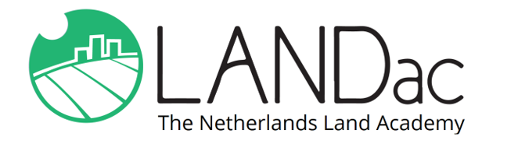
LANDac Annual
International
Conference
2022

29 June – 1 July

ABSTRACT SUBMISSION FORM
Deadline for abstract submission: 15 April, 2022

Land Governance for the Future – What (r)evolutions do we need?

Only use this form to submit your abstract. Submit your abstract to the contact person of your preferred session, with landacconference2022@gmail.com in CC. You will be notified about acceptance of your abstract by 1 May, 2022. Please mention the session code in communication.
Title of the session you want to submit your abstract to:

Code of the session you want to submit your abstract to:

Title of your abstract:

Name(s) and affiliation(s) of the authors:

Contact details of the presenting author:

Abstract (max. 250 words):

Alternative conference session of your choice (if this session is full):

Are you planning to join the conference on location or online:

